Day 1. Glasgow to lockerbie
Thursday September 12th 10 + 70 miles
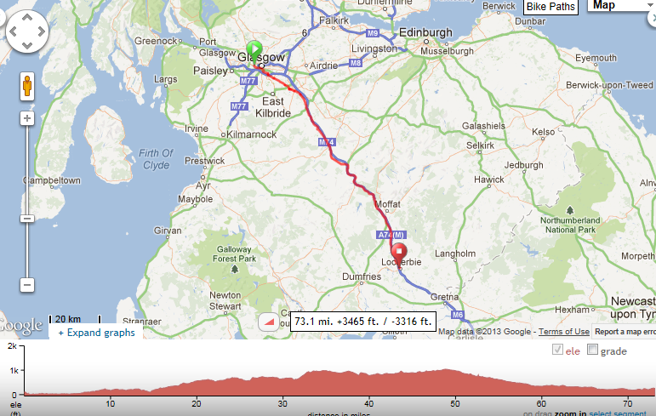
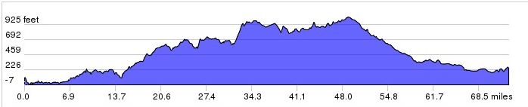

Day 2 Lockerbie to Kendal
Friday September 13th 73 miles
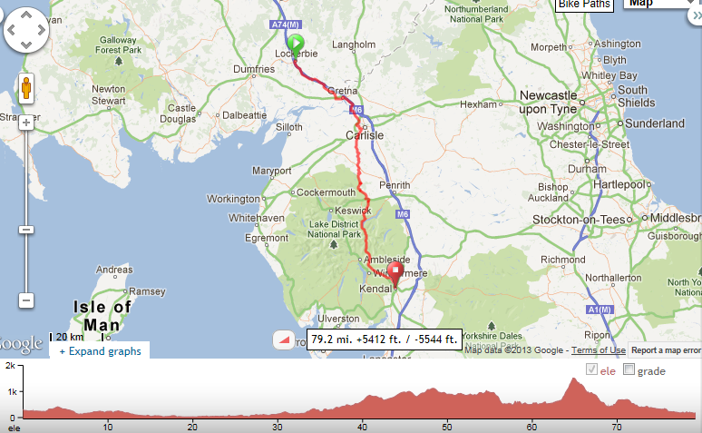

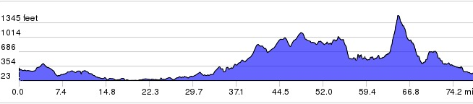

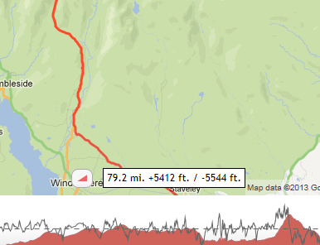
Steep bit is Kirkstone pass. 800ft Could avoid but its a longer route….
Day 3 Kendal to Manchester
Saturday September 14th
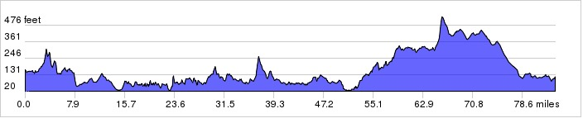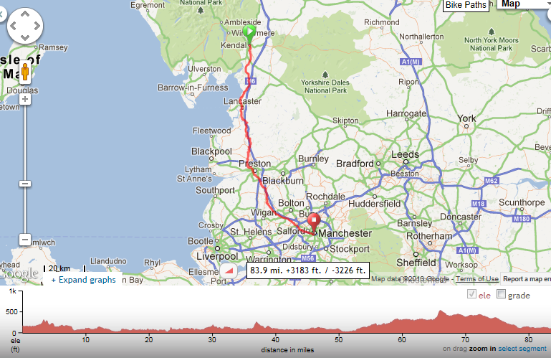

Day 4 Manchester to Sheffield
Sunday September 15th only 40 steep miles

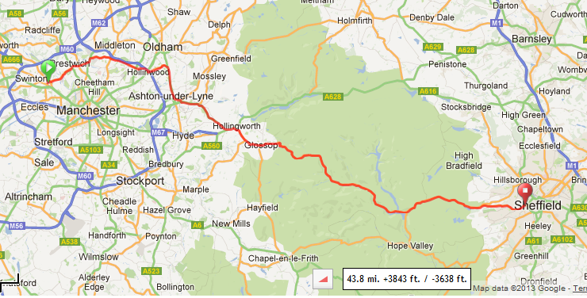

Snake Pass…1,100 ft Should be OK as only doing 44 miles that day
Or similar – Neil to decide

Day 5 Sheffield to Birmingham
Monday September 16th 80 miles
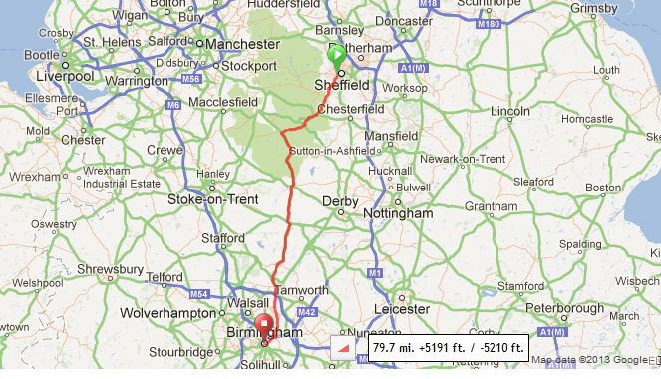
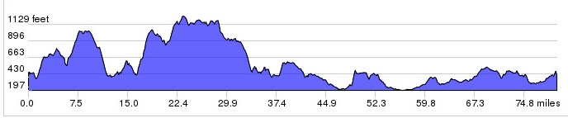
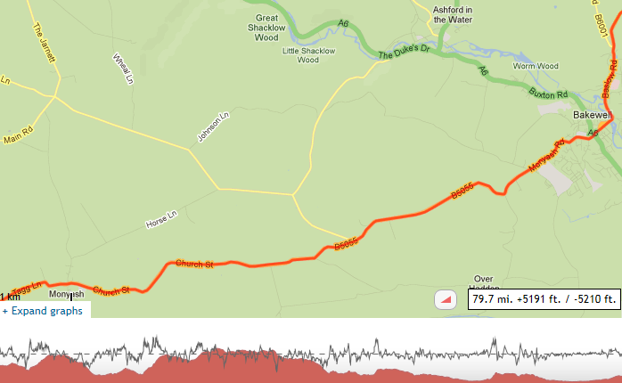
Road out of Bakewell 600ft!
Day 6 Birmingham to Bristol
Tuesday September 17th 90 miles
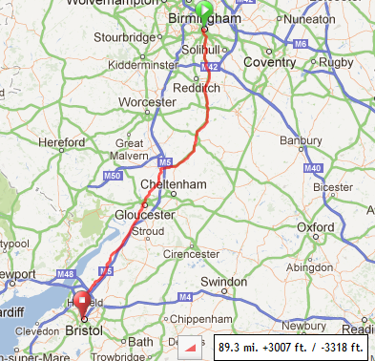

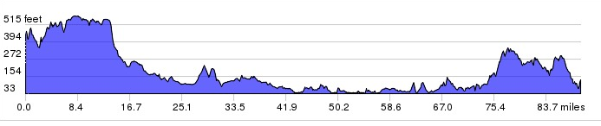

Day 7 Bristol to Oxford
Wednesday September 18th 85miles
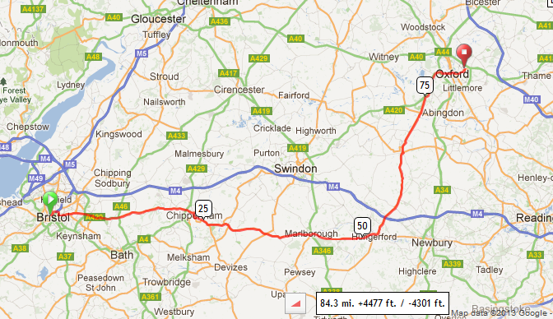
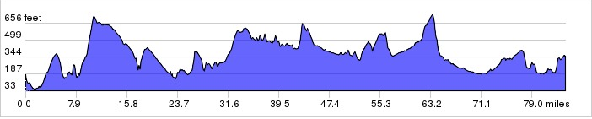

Day 8 Oxford to London
Thursday September 19th
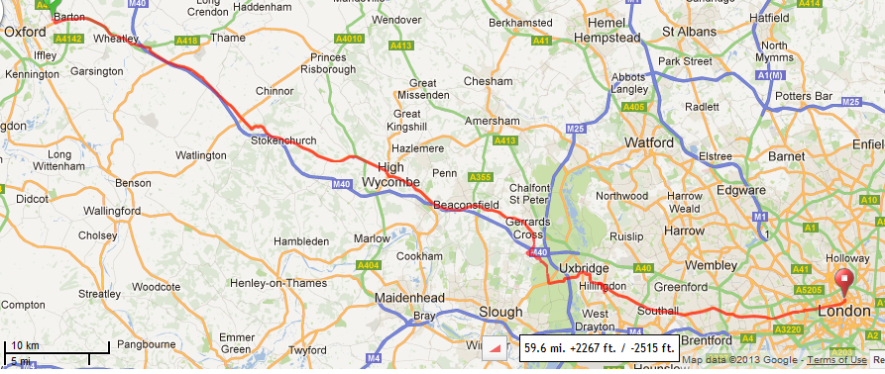
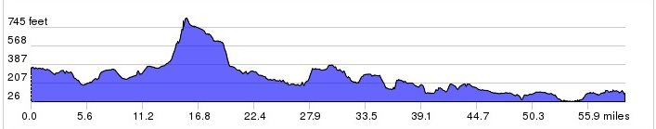
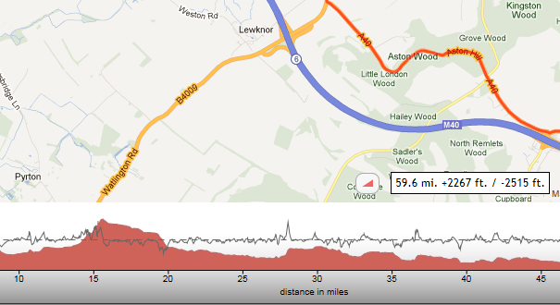
Ashton Hill 400ft !!!!

