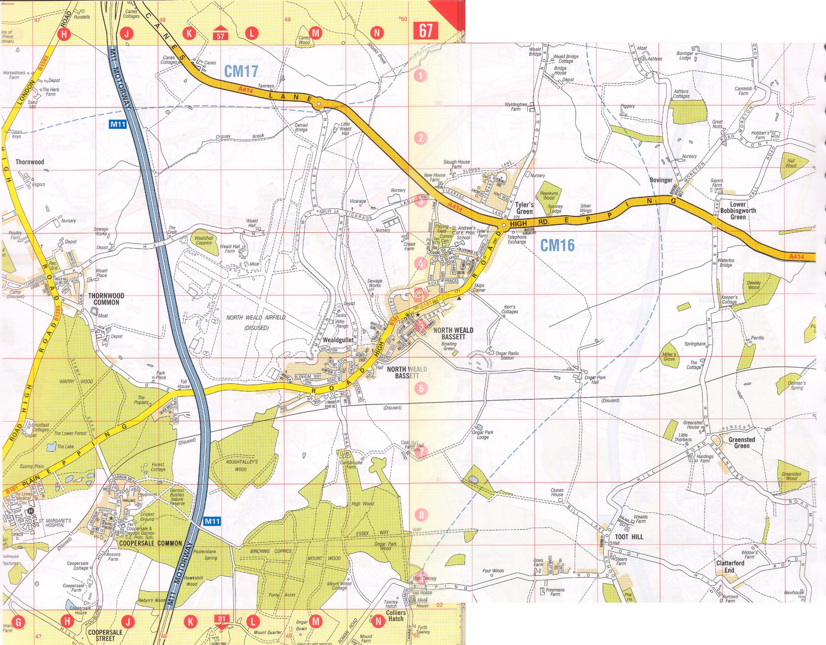

Ongar
Junction 7 from M11 towards Ongar
Across small r’bout at end of airfield
Across “Talbot” roundabout
Left towards Payphone, Bovinger and Moreton
“Muggins” is 7/10 mile from main road on right hand side.
Cream house with green windows.
Black wooden security gates

Muggins,
Moreton Road
Bovinger
Essex CM5 OLU

Tel 01277890039
Route from M11 J7 roundabout
07860198400
Past organic farm and travelodge
GPSLatitude | Longitude
N 51 43.923 | E 0 12.688

